Name :SK.Kashifa

Registration no :192121135

Library management system :

Class diagram :

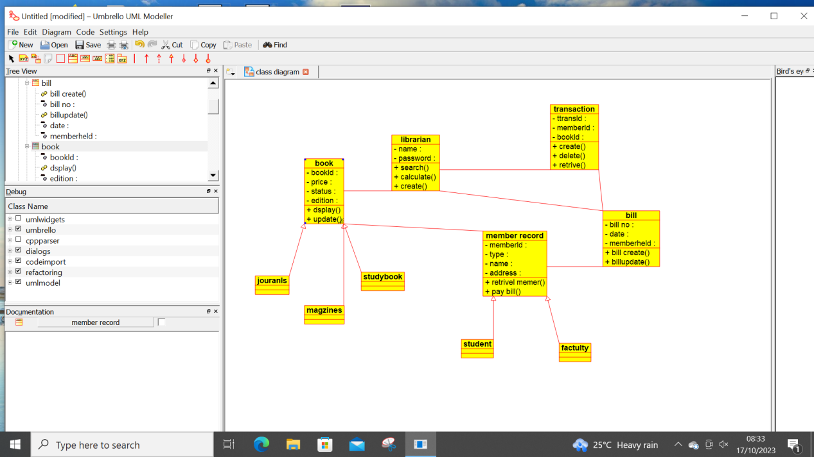

Activity diagram :

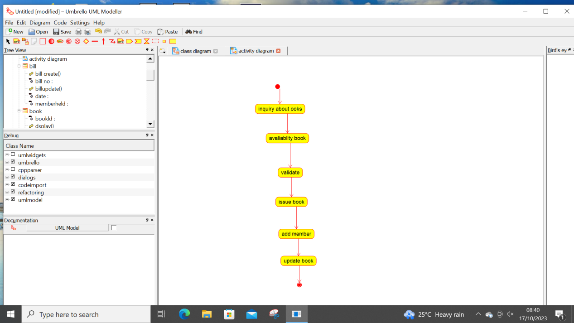

Sequence diagram :

